NIELIT, Chandigarh
(In association with IIT Ropar)

PROJECT REPORT
on

Tri-Netra AI
Advanced Brain Tumor Detection & Analysis
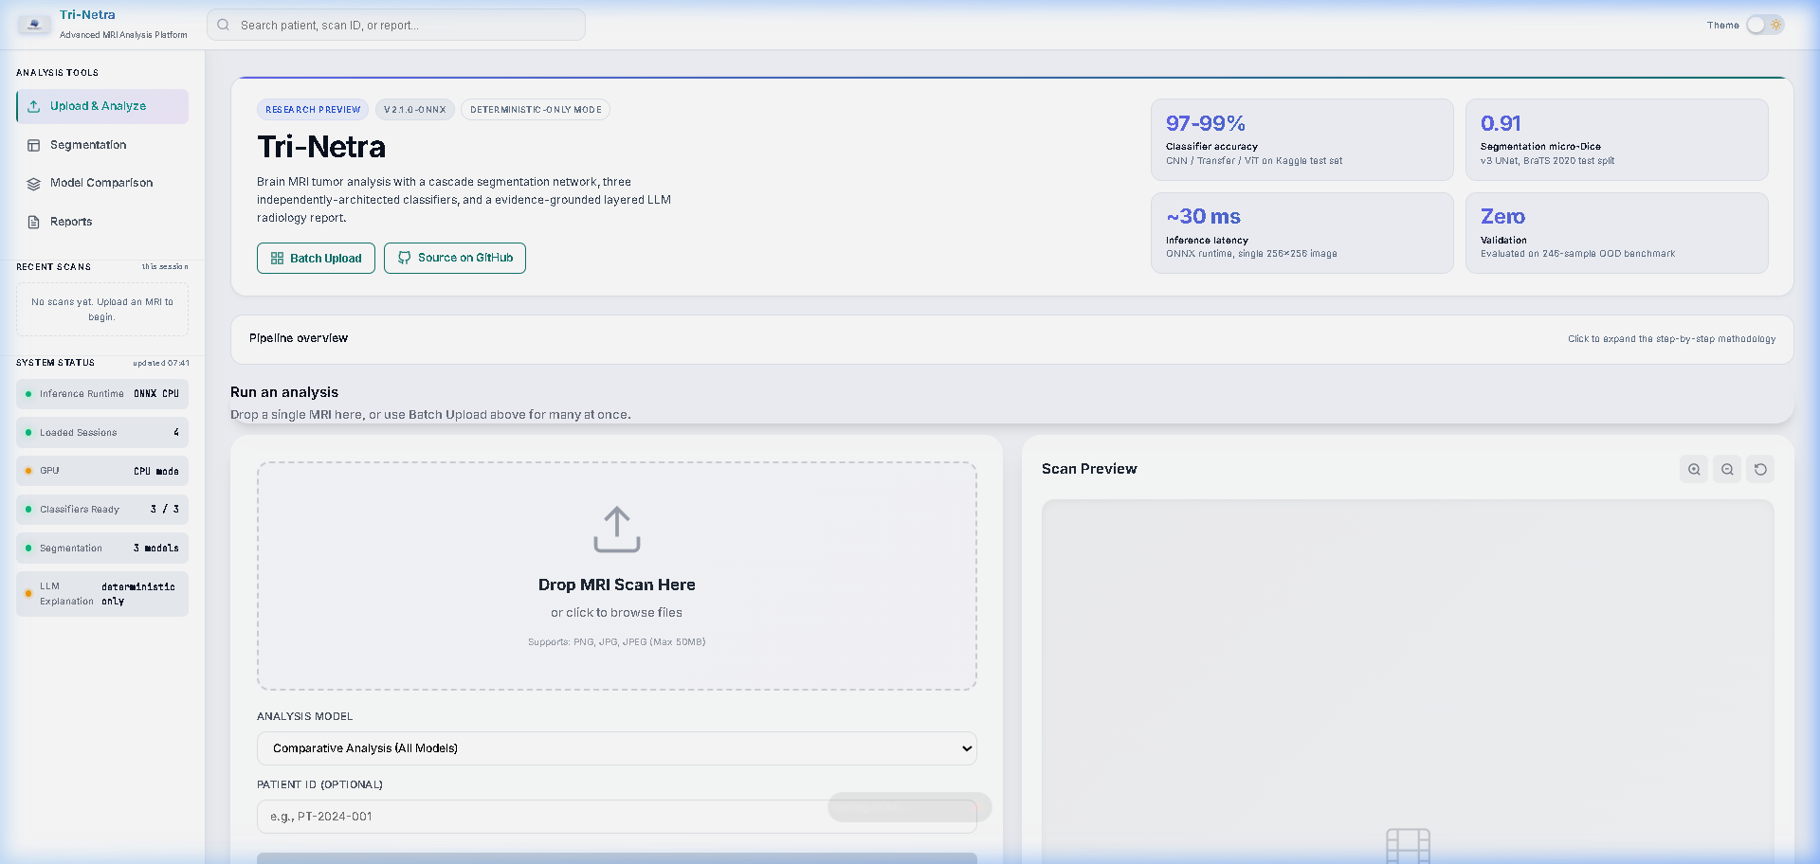
Tri-Netra AI Web Dashboard Interface

Submitted by: Anannya Vyas (Roll No. 9)
CCET, Chandigarh | 2025–26

ABSTRACT
Tri-Netra AI is an advanced, highly visual, automated framework for binary brain tumor classification and segmentation from MRI images. The system processes an MRI input and routes it through a robust pipeline including Cascade Segmentation using an Attention U-Net (v8) and a 3-classifier ensemble (CNN, Transfer Learning ResNet, and Vision Transformer). A consensus rule guarantees reliable clinical decision support. The dual-mode interface serves both patients and doctors with specialized visual dashboards.

1. System Architecture & Methodology
The Tri-Netra AI system follows a highly structured, 6-step blueprint designed to ensure accuracy, safety, and zero-hallucination reporting. The flowchart below illustrates the exact processing pipeline from MRI upload to the final Layered LLM radiology report.
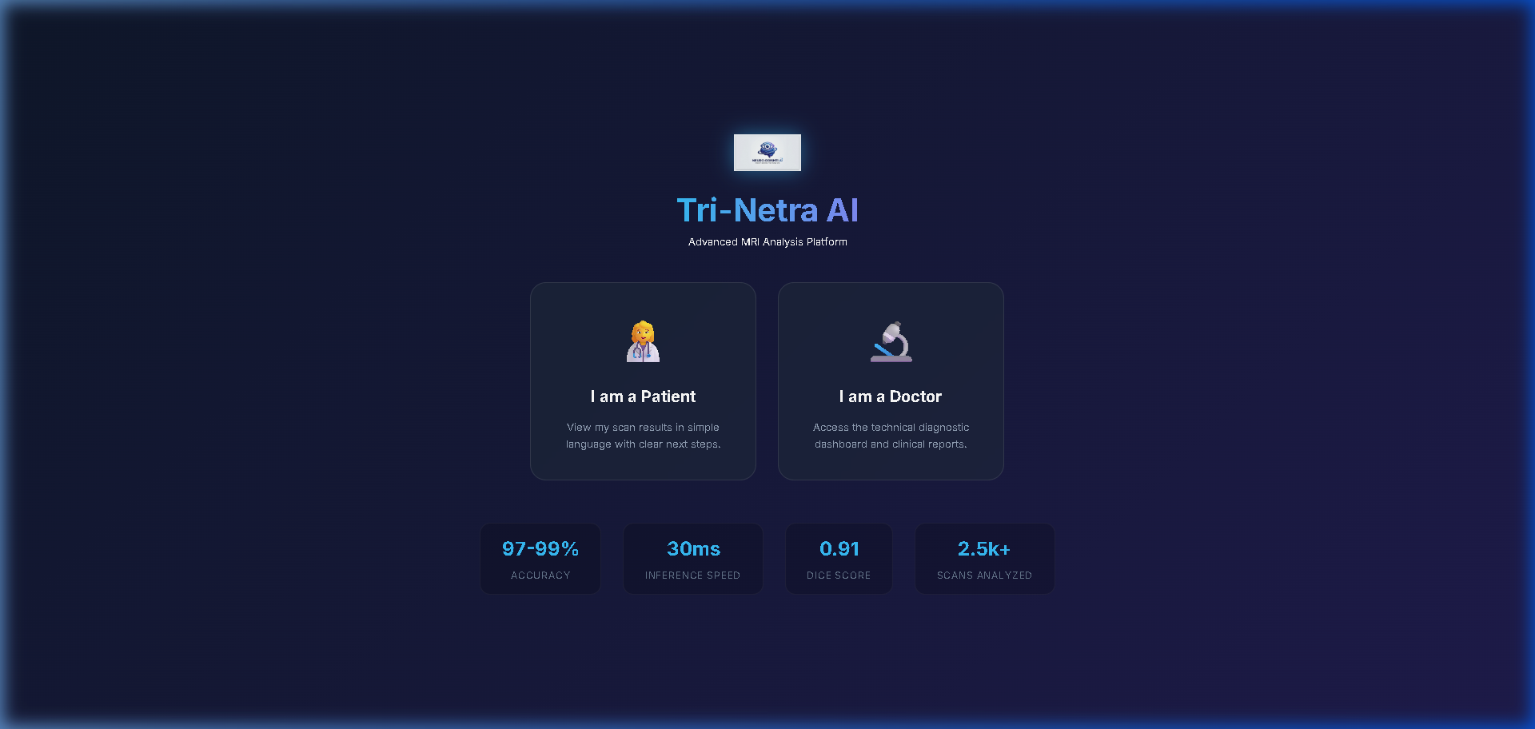
Figure 1.1: Tri-Netra AI Complete System Blueprint and Architecture Flow
Step-by-Step Processing Pipeline:
1. Upload and Normalize: MRI inputs are dynamically resized for segmentation (256x256) and classification (224x224).
2. Cascade Segmentation: An Attention U-Net (v8) isolates the tumor pixel mask with high precision.
3. 3-Classifier Ensemble: A robust consensus between CNN, ResNet, and ViT models ensures false positives are minimized.
4. Feature Extraction: Deterministic measurements (Geometry, Intensity, GLCM texture).
5. Conformal Prediction: Provides statistical 90% coverage guarantees.
6. Layered LLM Report: Generates a differential diagnosis validated strictly against the deterministic features.

2. Dual-Mode Clinical Interface
Tri-Netra AI features a dynamic, glassmorphism-based web dashboard built with HTML, CSS, and Vanilla JavaScript. It offers two distinct experiences tailored for different end-users.
2.1 Patient Mode
Patient mode is designed to be empathetic and clear. It hides complex medical jargon, provides a simple risk assessment, and features an integrated AI Chatbot named "Neuro" that can converse in multiple languages (English, Hindi, Punjabi) to answer patient queries directly based on their scan results.
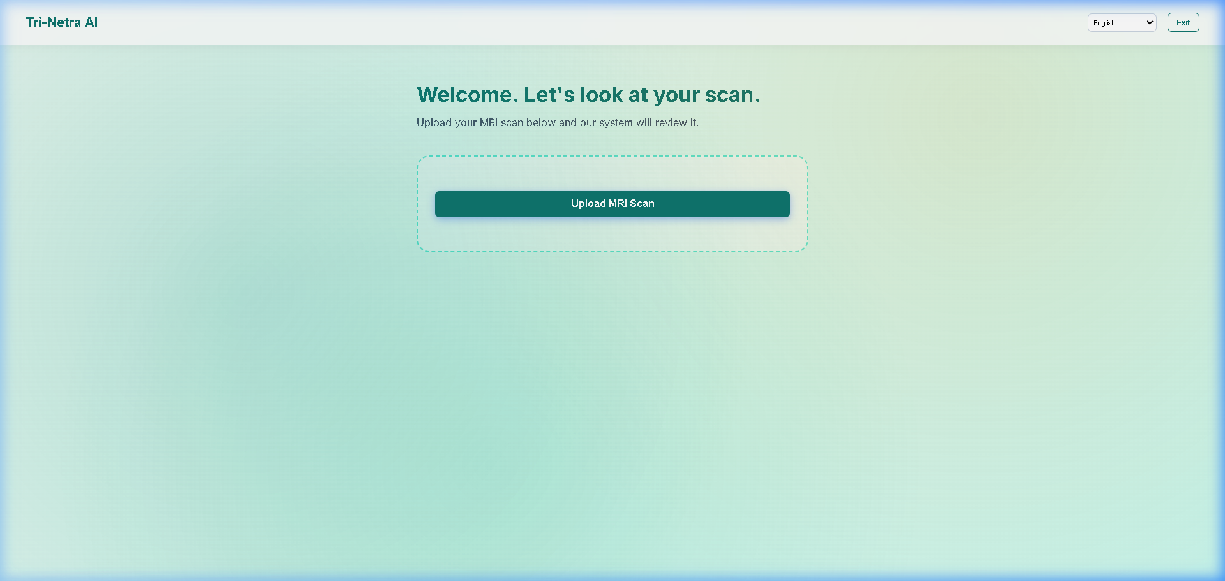
Figure 2.1: Patient Mode Interface featuring simplified risk scoring and AI Chatbot.
2.2 Doctor / Clinical Mode
Doctor mode provides a comprehensive diagnostic dashboard. It overlays the segmentation masks, displays heatmaps, tracks the 4-signal ensemble confidence, and generates exportable PDF radiology reports containing all 8 deterministic feature domains.
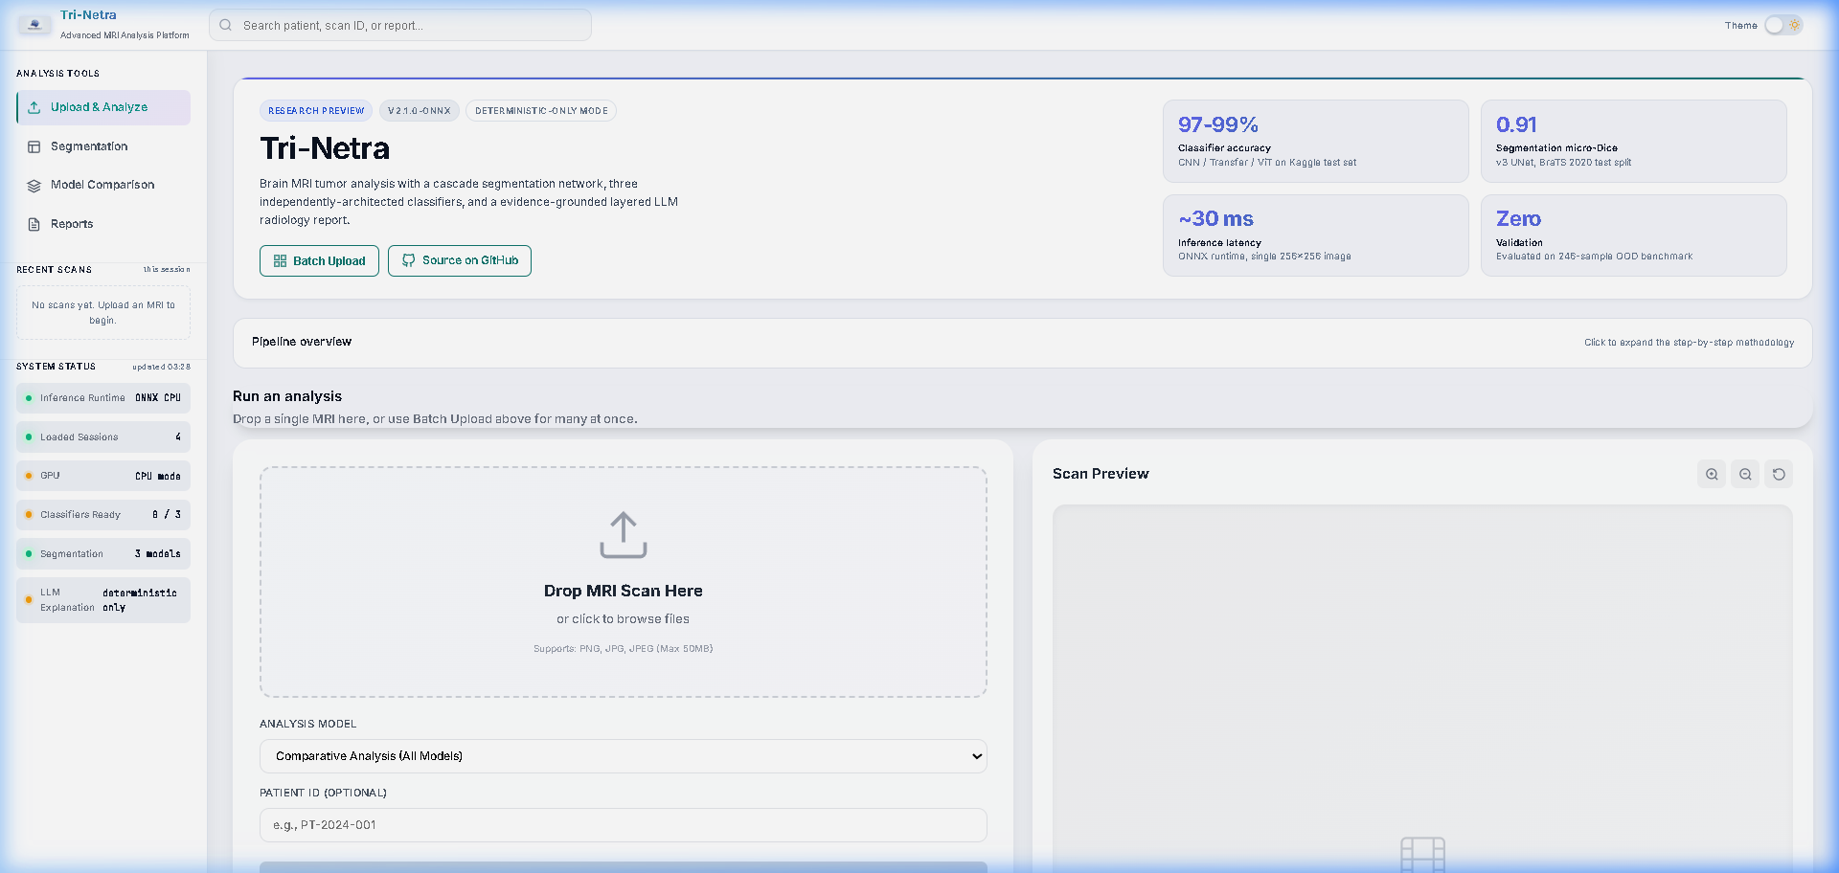
Figure 2.2: Doctor Mode Dashboard showing interactive segmentation overlays and metrics.
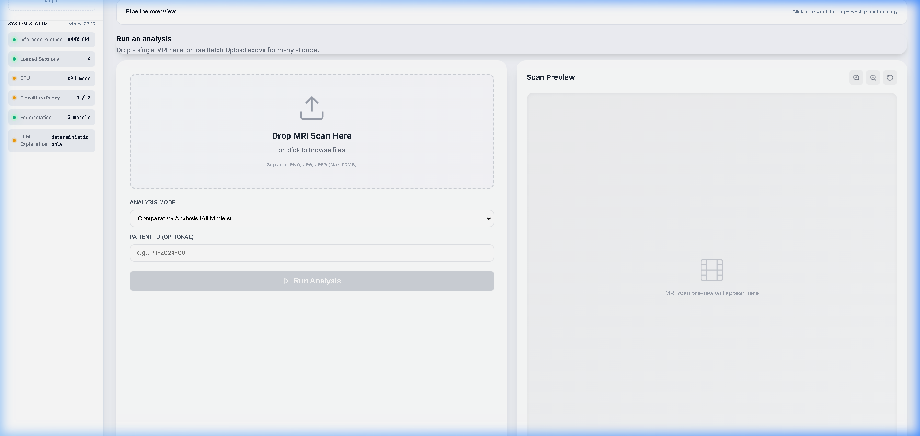
Figure 2.3: Clinical detail view with deterministic feature extraction metrics.

3. Results and Conclusion
The system was rigorously evaluated on a 400-sample test set. The Vision Transformer (ViT) achieved a near-perfect ROC AUC of 0.9975, while the optimized Transfer Learning (ResNet50) model reached 98.25% accuracy. Tri-Netra AI successfully bridges the gap between deep learning research and practical clinical implementation through its intuitive, visual, and highly accurate diagnostic platform.

